**Linux Basics :**

1. Linux is an open-source os . Unix is also an operatng system like Linux
2. It enables the communication between computer hardware and software.
3. It conveys input to get processed by the processor and brings output to the hardware to display it.
4. Linux was developed by ****Linus Torvalds**** in ****1991.****
5. Nowadays, Linux is the fastest-growing OS. It is used from phones to supercomputers by almost all major hardware devices.

**Structure Of Linux OS :**

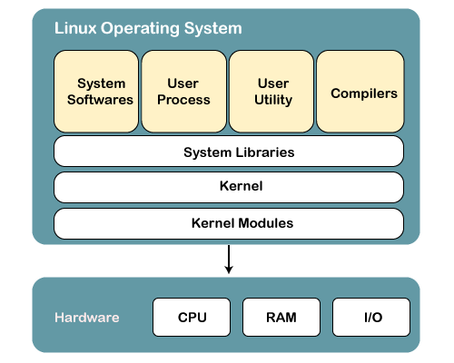

## 1) Kernel

Linux kernel is the core part of the operating system. It establishes communication between devices and software. Moreover, it manages system resources. It has four responsibilities:

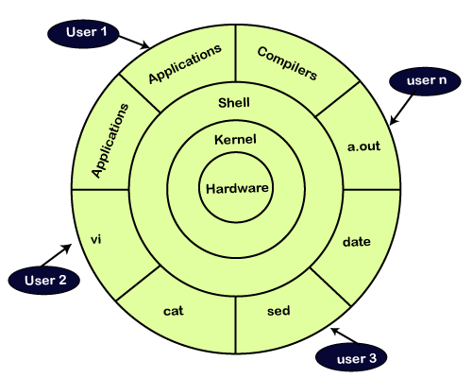

1. Device management-
2. Memory management -
3. Process management -
4. Handling system calls -

## 2.System Libraries -

It is responsible for make communication between kernel and user using different system call .

## 3.System Tools-

1. Linux OS has a set of utility tools, which are usually simple commands.
2. With the help of commands, you can access your files, edit and manipulate data in your directories or files, change the location of files, or anything.

## 4. Development Tools -

With the above three components, your OS is running and working. But to update your system, you have additional tools and libraries. These additional tools and libraries are written by the programmers and are called toolchain. A toolchain is a vital development tool used by the developers to produce a working application.

**5.End User Tools-**

It means end user required product .it is unique for end user .it is not for os

**# why use linux :**

1. It is secure
2. Open-source
3. It works on most of os easily so it is flexible with os

**#how to use it**

1. It used through commands or interactive user interface
2. To run linux from the terminal using “CTRL +ALT +T” keys.

**#Linux Directories -**

**1.Change directory -cd**

(base) root@kali:~# cd Desktop/

**2.make directory -mkdir**

(base) root@kali:~/Desktop# mkdir Go_Digital_Linux

**3.move from current directory to target directory-**

(base) root@kali:~/Desktop# cd Go_Digital_Linux/

(base) root@kali:~/Desktop/Go_Digital_Linux#

**4.remove directory-**

(base) root@kali:~/Desktop/Go_Digital_Linux# mkdir tushar

(base) root@kali:~/Desktop/Go_Digital_Linux# dir

tushar

(base) root@kali:~/Desktop/Go_Digital_Linux# rmdir tushar

(base) root@kali:~/Desktop/Go_Digital_Linux# dir

(base) root@kali:~/Desktop/Go_Digital_Linux#

**5.print working directory -pwd**

(base) root@kali:~/Desktop/Go_Digital_Linux# pwd

/root/Desktop/Go_Digital_Linux

**6.List out all directories of the current directories- ls**

(base) root@kali:~/Desktop/Go_Digital_Linux# ls

tushar